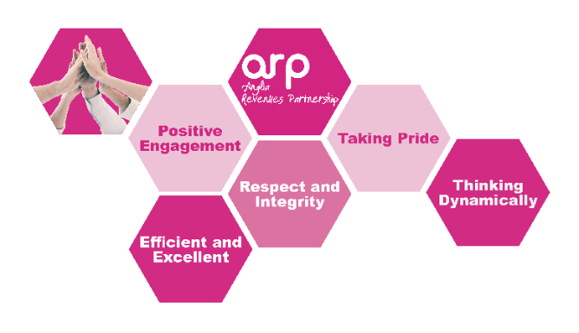

**PERSON SPECIFICATION**

**Job Title: Fraud Officer**

|  |  |  |
| --- | --- | --- |
|  | Essential | Desirable |
| **Qualifications & Experience** | Must have recent experience of working in a busy office environment or have relevant qualifications in this field  Excellent customer service skills  Minimum of 5 GCSE passes at grade C or above to include English and Mathematics or relevant experience  Demonstrate good numerical and writing skills  Experience of working in a team  Where not held, willing to undergo accredited training to expand on existing knowledge | Fraud investigation experience  Previous Local Government experience  Considerable experience within a similar environment  Two A-Level’s or equivalent  Accredited Counter Fraud Specialist (ACFS) or PINS (Professionalism in Security)  IRRV Technician |
| **Knowledge** | Knowledge of Capita (Academy), Civica and other computer packages, including the Microsoft Suite and have the sufficient knowledge and skill to be able to use IT effectively and efficiently. | Knowledge of the Police and Criminal Evidence Act  Experience of using the INTEC IDIS (data matching and credit report system)  Knowledge of criminal investigations  An understanding of Housing/Council Tax/Revenues legislation |
| **Skills** | Ability to gather and analyse facts and information  Ability to interpret relevant legislation/regulations  Ability to prioritise workload  Be able to work to tight deadlines and work effectively under pressure  Able to work on own initiative as well as part of a team | Ability to undertake Interviews Under Caution  Knowledge of Council Tax Support and general welfare benefits  Ability to prepare clear and concise reports to a standard required for use in criminal proceedings.  Knowledge of the criminal court system and delivery of evidence. |
| **Delivering excellent Customer Service** | Demonstrate experience or understanding of customer care.  Demonstrate ability to deal with customer enquiries in an appropriate, diplomatic, and professional manner.  Be able to remain calm during stressful/violent circumstances. | Customer Care training |
| **Health, Safety and Welfare** | Able to demonstrate good general understanding of Health, Safety and Welfare policies and procedures  Demonstrate ability to achieve a good work life balance for self and for team |  |
| **Striving for Continuous Improvement** | Commitment to a learning culture  Able to give examples of flexible and positive response to change |  |
| **Diversity and Equality** | Ability to understand the concept of diversity and respect for others and be committed to these issues |  |
| **Communicating effectively** | Good level of interpersonal and communication skills  Ability to communicate both orally and written  Effectively communicates relevant information to others  Able to respond to varying levels of understanding from customers |  |
| **Attitude** | Must be able to self-motivate and embrace change.  Be an effective team player and can work flexibly within a team  Have a positive desire to achieve results  Can work effectively under pressure and use own initiative  Willing to learn and improve  Can engage effectively with stakeholders at varying levels |  |
| **Other special requirements** | Full driving license and access to a vehicle |  |